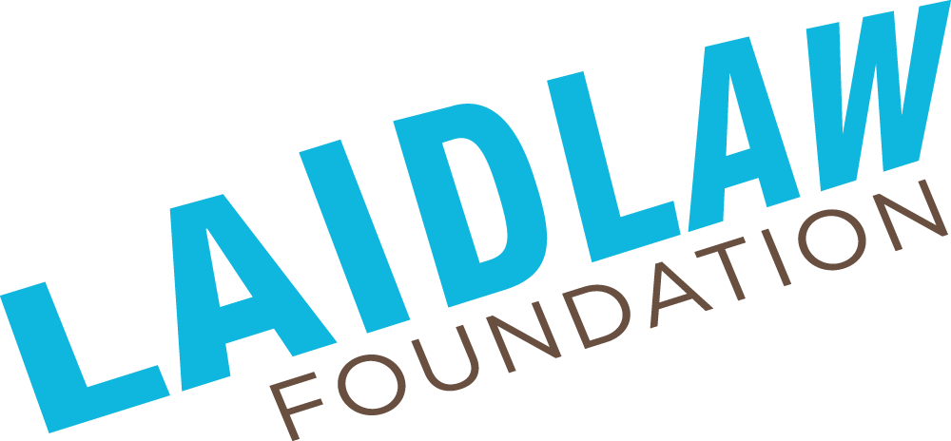
Mental Health Resources

Mental Health Training Resources
- Mental Health First Aid: Training program that teaches individuals how to provide initial help to someone who may be experiencing a mental health crisis or developing a mental health problem. Available in-person and online and offered by organizations such as the Mental Health Commission of Canada and the Canadian Mental Health Association.
- Applied Suicide Intervention Skills Training (ASIST): Two-day workshop that provides participants with skills to intervene and prevent suicide. Offered by organizations such as the Canadian Mental Health Association and LivingWorks.
- SafeTALK: Half-day training program that teaches participants how to identify individuals who may be at risk of suicide and how to connect them with appropriate resources. Offered by organizations such as the Mental Health Commission of Canada and LivingWorks.
- Mental Health Works: Training program that provides organizations and individuals with the skills to support and promote mental health in the workplace. Offered by the Canadian Mental Health Association.
- Identify, Assist, Refer: Education module that provides you with the basic skills and information needed to support people experiencing mental health challenges, whether or not they live with a mental illness.
- Radical Mental Health First Aide: Workshop offers context on the impact of oppression and social injustice on the body-mind and teaches de-escalation and consent skills.
- CharityVillage Mental Health Guide: Included in this guide is normalizing conversations about mental health, common challenges and how to address them, providing support for mental health issues, addressing workload, enhancing the work experience and more strategies and tips!

Mental Health Safety Plan
When writing a safety plan for a youth project, it's important to take into account the unique needs and cultural considerations of the community. Here are some steps to follow when writing a safety plan for a youth project:
- Engage with the community: Consult with elders, community leaders, and other stakeholders to understand the cultural protocols and values that need to be taken into account when developing a safety plan.
- Identify potential risks or harms: All projects have the potential for harm. Identify any and all potential harms that could be associated with the project, including emotional, physical, environmental, and cultural hazards. This can be done by conducting a risk assessment or consulting with experts.
- Develop plan to reduce risk: Once you have identified possible harms , develop a plan to reduce the risk or severity of harm caused. This might include providing appropriate safety equipment, support staff, implementing cultural protocols, or modifying project activities to reduce risks.
- Establish emergency procedures: Develop clear emergency procedures for responding to incidents or emergencies. Make sure that all staff, volunteers, and participants are aware of these procedures and know what to do in the event of an emergency.
- Train staff and volunteers: Ensure that all staff and volunteers are trained in the safety procedures and protocols specific to the project. This may include training on first aid, emergency response, and cultural awareness.
- Review and update the plan regularly: Regularly review and update the safety plan to ensure that it remains relevant and effective. Seek feedback from community members, staff, and volunteers to identify areas for improvement and make necessary changes.

Mental Health Call Lines
- Hope for Wellness Hotline Crisis Counselling: Available to all Indigenous people across Canada. Experienced and culturally competent counsellors are reachable by telephone and online ‘chat’ 24 hours a day, 7 days a week. Call 1-855-242-3310 or visit https://www.hopeforwellness.ca to chat online.
- 2-Spirits Mental Health Crisis Line: An Indigenous-specific mental health crisis support line for those living in the GTA. 2PM-2AM daily. Call 416-363-2999 or visit https://www.callblackline.com.
- Blackline: A 24/7 volunteer run hotline (accepts calls or texts), Blackline provides a space for peer support & counselling, reporting of mistreatment, affirming the lived experiences of people who are most impacted by systemic oppression with an LQBTQ+ & Black femme lens. Call or text 1-800-604-5841 or visit https://www.callblackline.com.
- Caribbean-Canadian Crisis Textline: Confidential crisis support by text for people who have Caribbean heritage/ethnicity. Text HELLO to 1-855-574-0574.
- Equitable Action for Change: Community support hotline offering free counselling for African, Black, and Caribbean Communities. Call 1-855-574-0574 every Friday between 12-4pm.
- Trans Lifeline Canada: Connects trans people to the community support and resources needed to survive and thrive. Offers direct emotional and financial support to trans people in crisis – for the trans community, by the trans community. Call 1-877-330-6366 for Canada or visit https://translifeline.org.
- LGBT Youthline: Offers confidential and non-judgemental peer support through phone, text and chat services. Get in touch with a peer support volunteer from Sunday to Friday, 4:00PM to 9:30 PM. Call, text 647-694-4275 or visit https://www.youthline.ca.
- National Overdose Response Service (NORS): Overdose prevention hotline for Canadians providing loving, confidential, nonjudgmental support, whenever and wherever you use drugs. Call 1-888-688-NORS(6677), visit https://www.nors.ca or use the Brave App.
- Kids Help Phone: Provides 24/7 support for young people in Canada. Offer a helpline, online chat, and resources for young people experiencing mental health concerns. Call 1-800-668-6868 or visit www.kidshelpphone.ca.
- Talk Suicide Canada: Connect to a crisis responder to get help without judgement. Available 24/7 365 days for calls and 4PM-midnight EST for texts. Call 1-833-465-4566, text 45645, or visit https://talksuicide.ca.
- Ontario Mental Health Helpline: Available 24/7 to provide free and confidential support for individuals experiencing mental health concerns. Call 1-866-531-2600 to speak with a mental health professional.
- ConnexOntario: Provides free and confidential health services information for people experiencing problems with alcohol and drugs, mental illness or gambling. Offer a helpline, online chat, and email support. Call 1-866-531-2600, text CONNEX to 247247, or visit www.connexontario.ca.
- Centre for Addiction and Mental Health (CAMH): CAMH is a mental health and addiction facility located in Toronto. They offer a range of services, including assessments, treatment programs, and research. Visit www.camh.ca.
- Big White Wall: Big White Wall is a digital mental health and wellbeing service that provides 24/7 online support and resources. It offers a supportive community, self-help resources, and professional support. Access it through the Ontario Telemedicine Network or visit www.bigwhitewall.com.
For Unity: a Mental Health and Anti-Racism Resource Guide developed by Helping Hands, please click here.
For other Ontario and Canada-Based Mental Health Resources developed by Phuong Nguyen, please click here.

